**Leading University**

**Department of Computer Science and Engineering CSE 4801**



**LUResource**

Pritom Joyti Talukdar

Sagor Mojumdar

Nishat Anjum Chowdhury

1912020117

1912020150

1912020100

Department of Computer Science and Engineering

**Supervisor**

Md Jamaner Rahaman

Lecturer

Department of Computer Science and Engineering

**Recommendation Letter from the Project/Thesis Supervisor**

The project entitled *LUresource* submitted by the students

1. Pritom Joyti Talukdar
2. Sagor Mojumdar
3. Nishat Anjum Chowdhury

is a record of research work carried out under my supervision and I, hereby, approve that the report be submitted in partial fulfillment of the requirements for the award of their Bachelor Degrees.

Signature of the Supervisor:

Md.Jamaner Rahaman

Date: 14th March, 2023

**Certificate of Acceptance of the Project/Thesis**

The project entitled LUResource

submitted by the students

1. Pritom Joyti Talukdar
2. Sagor Mojumdar
3. Nishat Anjum Chowdhury

on 14th March, 2023

is, hereby, accepted as the partial fulfillment of the requirements for the award of their Bachelor Degrees.

**Head of the Dept.**

Rumel M. S. Rahman Pir

Associate Professor & Head

Department of Computer

Science and Engineering

**Chairman, Exam. Committee**

Shafkat Kibria

Assistant Professor

Department of Computer

Science and Engineering

**Supervisor**

Md. Jamaner Rahaman

Lecturer

Department of Computer

Science and Engineering

# Abstract

LUResource is an innovative website designed to enhance the academic experience of students and faculty members at Leading University. With its user-friendly interface, the website offers a range of features, including sign in, sign up, email verification, notice portal, faculty, and resource upload and delete for faculty members. It simplifies the process of sharing academic materials like images, PDFs, videos, and notices, providing easy access to valuable academic content. Additionally, the website offers a secure and private platform for faculty members to share academic resources with their intended audience. Overall, This website provides a centralized platform for sharing academic resources between teachers and students.

# Acknowledgements

We feel immensely grateful to the Almighty for providing us with the opportunity to successfully complete our project. We owe a debt of gratitude to our parents, whose love, sacrifice, and prayers have played a pivotal role in bringing us to this stage of our education.

We extend our heartfelt appreciation toward our all the faculty members, particularly our supervisor, Md. Jamaner Rahaman, Sir, whose invaluable support, guidance, and supervision were instrumental in bringing our project to fruition.

Lastly, all gratefulness to those people who helped us by sharing their knowledge, advice and expertise during the development of the project.

# Dedication

All the honorable teachers, students and corroborative staffs of the Department of Computer Science and Engineering of the Leading University who have provided untiring effort and helped us to complete our work.

Also, to our beloved parents for their unconditional love, support and prayers.

# Contents

Abstract 4

Acknowledgements 5

Dedication 6

Contents 7

List of Figures 8

Introduction 9

1.1 Background 9

1.2 Background 2 9

Why do we use it? 9

1.3 Motivation 10

Background Study 11

2.1 Review Previous Work 11

Chapter 3 12

Methodology 12

Structural Design 14

4.1 Class Diagram 14

4.2 E-R Diagram 15

4.3 Use Case Diagram 16

4.4 Data Flow Diagram 17

Chapter 5 19

Result and Analysis 19

Limitations and Future Work 20

6.1 Limitations 20

6.2 Future Work 20

Conclusion 21

References 22

# List of Figures

4.1 Class Diagram . . . . . . . . . . . . . . . . . . . . . . . . . . . . . . . . . . . . 8

4.2 E-R Diagram . . . . . . . . . . . . . . . . . . . . . . . . . . . . . . . . . . . . 9

* 1. Use Case Diagram 10

**Chapter 1**

# Introduction

## Background

The purpose of creating LUResource is to provide an easy and secure platform for faculty members and students of Leading University to share academic resources. The website aims to streamline the process of sharing academic materials between faculty members and students, promoting collaborative learning and enhancing the quality of education at Leading University.

## Background 2

## Why do we use it?

In traditional classroom settings, sharing academic materials can be challenging, with students often having to physically visit faculty members to access the necessary resources. With LUResource, faculty members can easily store and share academic materials online, ensuring that students have access to a wealth of valuable resources at all times.

The background for creating this website was the increasing demand for online education and the need for better platforms to facilitate virtual learning. With the ongoing pandemic, online education has become more crucial than ever, and LUResource is designed to meet this growing need.

The website also serves as a centralized database for academic resources, making it easier for faculty members to manage their materials and keep them organized. Overall, the creation of LUResource reflects the commitment of Leading University to providing its faculty members and students with cutting-edge technology to enhance the learning experience.

## Motivation

LUResource is a website for faculty members of LU where they can store their work-related documents in the form of pdf, word files, video, pptx, xlsx,jpg,png, etc. along with their own files, from where they can easily access their uploaded resources such as their course-related documents, they can also delete unnecessary documents, they can post notices, and they can visit profiles of other faculty and students and resource uploaded by them. Instead of accessing various sources, which requires time, the faculty can accomplish all of this work using only one website.

To promote collaborative learning is one of the primary motivations behind creating LUResource. The website provides a platform for sharing academic resources, enabling students to access a wide range of materials and facilitating collaborative learning.

Another motivation is to enhance the quality of education at Leading University. This website makes it easier for faculty members to manage their materials and keep them organized, ensuring that students have access to the most up-to-date and relevant resources. This website provides a platform for faculty members to upload and share academic resources, making it easier for students to stay connected with their teachers and access valuable learning materials.

Overall, the motivation behind creating LUResource could be to enhance the learning experience for faculty members and students at Leading University, promote collaboration and communication, and meet the growing demand for online education.

**Chapter 2**

# Background Study

## 2.1 Review Previous Work

There is currently no web platform or app that students and professors at our university can use to share academic resources based on their courses and upcoming announcement.

As a result, university students at our institution communicate in the departmental Facebook or WhatsApp Group to view the course-related resources.

But as the course-related resources uploaded in the group before the exam, this is not the best option.

Due to the fact that the majority of the students at our university attend our department, it is the largest department at our university. As a result, our department will have a large community, just like our departmental Facebook group. Our group receives many daily posts from a huge number of people, which causes important data to be ignored. Hence, it is not a perfect system and the majority of students cannot get assistance with respect to important notices. Hence, in order to prevent this outcome, we built this website ,to get all the materials in one place at a time

# Chapter 3

# Methodology

The methodology of LUResource involves creating a user-friendly platform that facilitates easy sharing of academic resources between faculty members and students.

The website has been designed with features like sign-up, sign-in, and email verification to ensure secure access to its resources. Faculty members can upload academic resources like images, PDFs, and videos and can choose whether to make them public or private. The website provides a centralized database for academic resources, making it easier for faculty members to manage and organize their materials. The methodology focuses on enhancing collaboration and communication between faculty members and students, promoting collaborative learning, and enhancing the quality of education at Leading University.

**System Requirements**

* Microsoft Windows / Mac OS / Linux
* 8 GB Ram.
* 20 GB Disk Space
* A faster processor
* Visual Studio Code
* Html, CSS, JavaScript
* Bootstrap
* PHP
* XAMPP Control Panel
* MySql
* Draw.io

**Features**

* Multiple user end(Teachers, students)
* Signup
* Signin
* Signout
* Email verification
* User Profile
* Profile Update
* File upload, delete, edit
* File download
* Notice update
* Restriction for non-registered user
* View restriction for faculty while uploading file
* Search bar(under construct)
* File sort using course code
* File uploader information with time
* Super admin to maintain role and other task
* Faculty members information with their uploaded content
* Contact with faculty through website

**Chapter 4**

# Structural Design

## Class Diagram

Insert the class diagram here 4.1

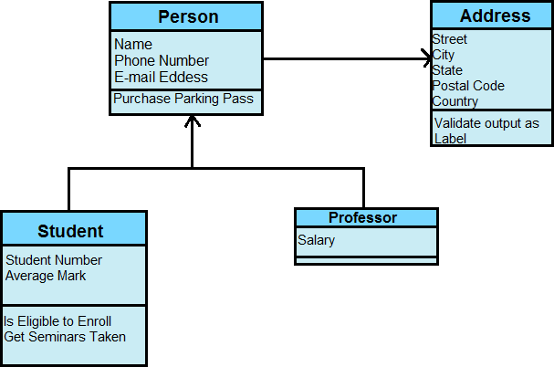

Figure 4.1: Class Diagram

## E-R Diagram

Insert the E-R diagram here 4.2

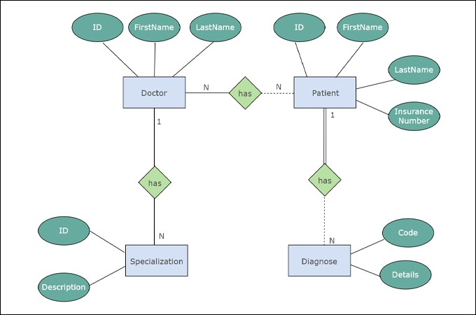

Figure 4.2: E-R Diagram

Figure 4.2 shows the ER-diagram.

## Use Case Diagram

Insert the Use case diagram here 4.3

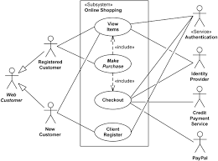

Figure 4.3: Use Case Diagram

## Data Flow Diagram

Insert the data flow diagram here 4.4

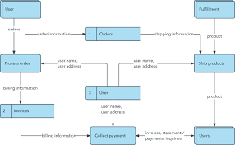

Figure 4.4: Data Flow Diagram

# Chapter 5

# Result and Analysis

**Chapter 6**

# Limitations and Future Work

## Limitations

* There is no reatime chat option among users.
* Only G suite account holder can gain full access to the website
* This website aims to provide a centralized database for academic resources, it may have limited storage space, which could restrict the amount and size of resources that can be uploaded.
* This website will not provide notification while new content is added.
* It is heavily dependent on internet connectivity, which could impact its usability in areas with poor or unreliable internet connectivity.

## Future Work

* The website could be updated with an improved user interface, making it more user-friendly and easier to navigate.
* The website could be updated with advanced search functionality, enabling users to search for specific resources more easily.
* The website could be updated to expand its storage capacity, allowing users to upload and access more resources.
* The website could be updated to integrate with social media platforms, enabling users to share resources with a wider audience.
* Realtime chat feature between the user and notification.

**Chapter 7**

# Conclusion

In conclusion, LUResource is a web-based platform designed for the faculty and students of Leading University to share academic resources.

While the website has some limitations, it has the potential to be updated with advanced features to improve its usability and effectiveness.

Overall, LUResource is a valuable tool for the Leading University community, providing an easy and convenient way to share academic resources.

# References

1. Background Study: HTML,CSS, Bootstrap,PHP ,MySQL Tutorial
2. https://www.w3schools.com/ Retrieved date: 29 March, 2022